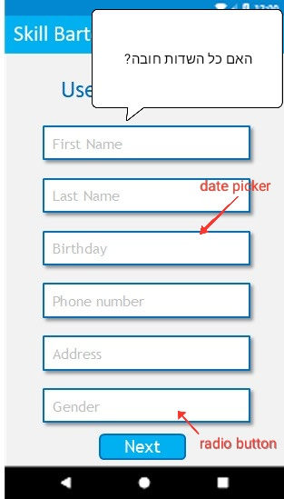

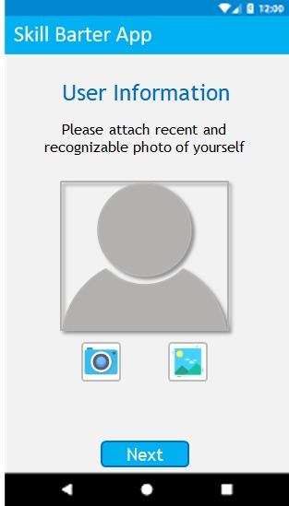

Add “prev” button

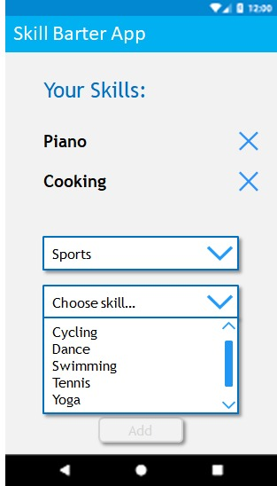

Add button to save the configurations

SEARCH SCREEN

Too much for one screen – consider making stages with “next”/”prev” buttons

HOMEPAGE SCREEN

Navigate to all the functionalities from it

Display all the necessary user data

FLOW MAP

<https://www.pinterest.com/pin/394909461068449256/feedback/?invite_code=8667fcd0902942589bafc01e279e396f&sender_id=542613592512399101>

<https://www.pinterest.com/pin/87820261467516753/feedback/?invite_code=775e25ac787f4d1b88d94186d0670aea&sender_id=542613592512399101>